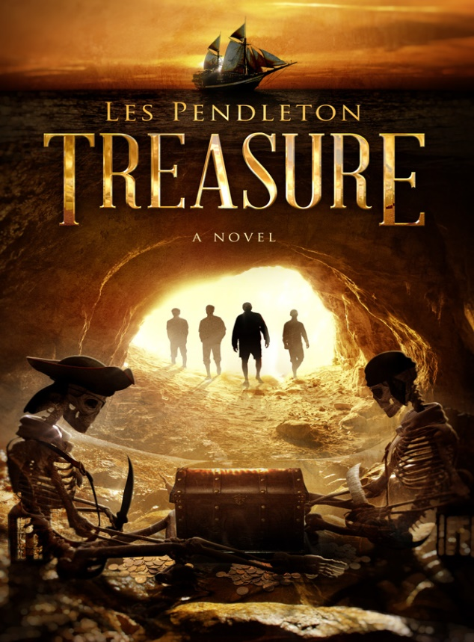
Four old friends set out on a two-week sailing vacation in the Florida Keys. These men need a break in their work-a-day lives. Jobs they hate, failing marriages and monotony control their world. They all want a change and a sailing trip seems to be the answer. Before the sailing begins, they’re diverted by a salty character named Bones offering them a high seas adventure as crew on his 90 foot schooner that they cannot refuse. He has the boat, but is just too old and infirmed to take such a large vessel out without a crew. A luxury he can no longer afford. With their help and his boat, they become the perfect team. Once underway, they are entranced by clear warm water, surviving storms at sea, and sailing on a starlit ocean. They are completely hooked on the adventure. The excitement over two weeks of sailing fades quickly when they realize there is a covert reason for Bones’ sailing trip. Have they fallen into the trap of a delusional madman who talks of Mayan gold, pirates and buried treasure? By then, turning back is not an option. Deception, drug cartel thugs, new loves and intense encounters on land and sea keep you on the edge of your seat. ‘It’s Treasure, mates’ but not what any of them expected.

