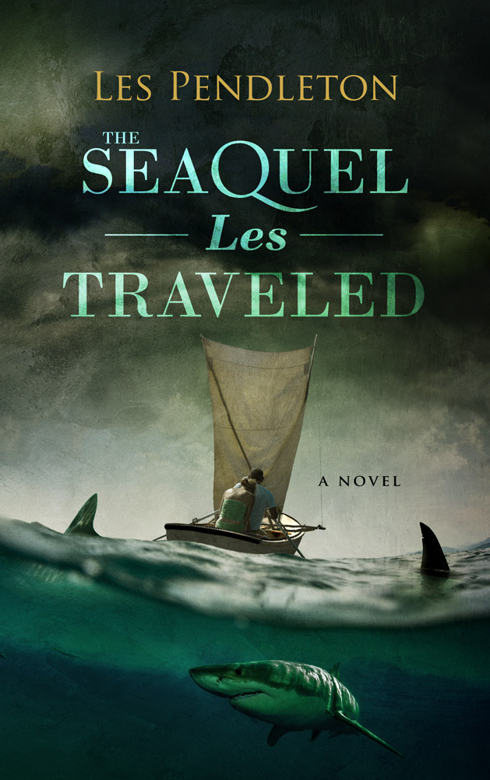
The continuing voyage of Cappy and Essie as they head toward palm trees, clear water and adventure. This “unlikely but mostly true tale” will have you wondering if it’s time for you to cut your own dock lines, kick ordinary to the curb, and follow the wind in a different direction. Only halfway to fulfilling their dreams, Cappy and Essie are again thrown to the wolves by a world that doesn’t want them to escape. Every time they see an opening, it’s slammed shut in front of their eyes. It has become a test to see if they can continue on when nothing seems to work out. Is it really possible to carve out a new life in a more beautiful place or should they pick up the pieces of their past lives and try to make the best out of what they had before? They are not dissuaded easily from their dreams. With the help of friends and more than a few twists of fate, they continue on through storms, old lives chasing them, and a few really bad people to find the paradise they have been chasing.

