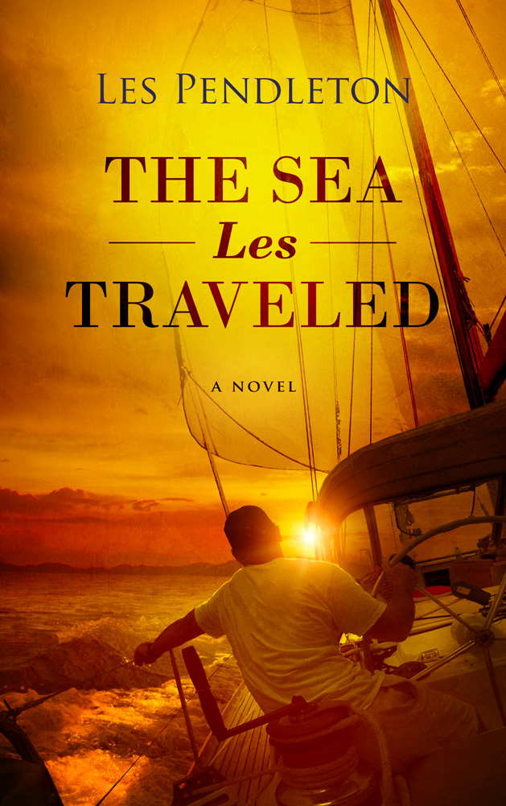
If life is turning out to be somewhat less than what you hoped for, you might want to set sail with Cappy and Essie as they throw their ordinary lives to the curb and follow the wind to adventure and romance. This “mostly true” story shows us that it’s never too late to set your compass on the right course. From different generations, Cappy and Essie meet under a highly unlikely scenario and embark on one of the most unusual and entertaining adventures ever taken under sail. This semi-autobiographical tale takes you with author Les Pendleton and his wife, Susanne, on a cruise from their personal prisons to the life of adventure they wove together with the help of a salty crew and their trusty sloop, Calypso. All of the characters and photos are real people using their real names. Many of the places and events are also real though rearranged chronologically and perhaps slightly enhanced so that the author could enjoy writing about the events as much as he did living them. You’ll find yourself completely absorbed by their adventures as they chase palm trees and sunshine. In short order you’ll be saying...”I need to make a change like this”. So, grab a cold drink and kick back. You’re about to change your latitude!

