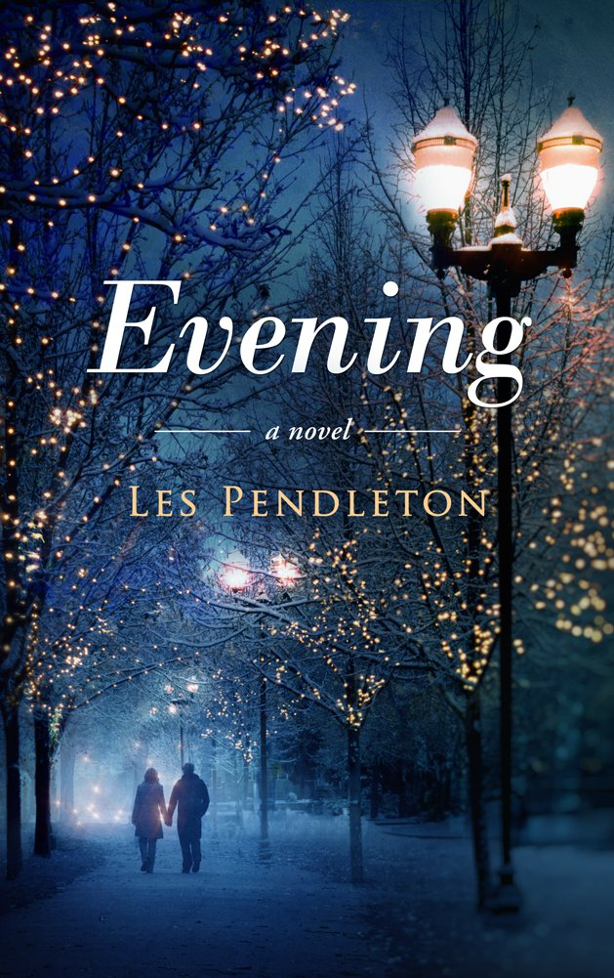
There is a time in women’s lives when they ask themselves…”Did I accept less than love?” Eve Browning is middle aged and growing disillusioned with everything in her life. She understands only too well that she chose security and comfort over love. Now she has to deal with the reality of a loveless marriage and unfulfilled dreams. With her kids almost grown and a disinterested husband, she faces a new sense of desperation in her life. To clear her head, she drives back to the small town of New Bern, North Carolina. She had grown up there and it gave her a feeling of warmth and comfort just to walk the streets for an evening. She had no thought of taking her life in a totally different direction. A chance encounter that evening forces her to decide whether to throw away all she has for the one thing she doesn’t, a real love. But before she can even consider making that decision, life complicates the issue more than she could ever imagine. The clock is running and she is staring at the dark room her life has become. Life choices are never simple and hers is no exception. And sometimes life itself will make decisions for us that we may not have the strength or will to make for ourselves. Eve must choose how she will spend the Evening of her life.

