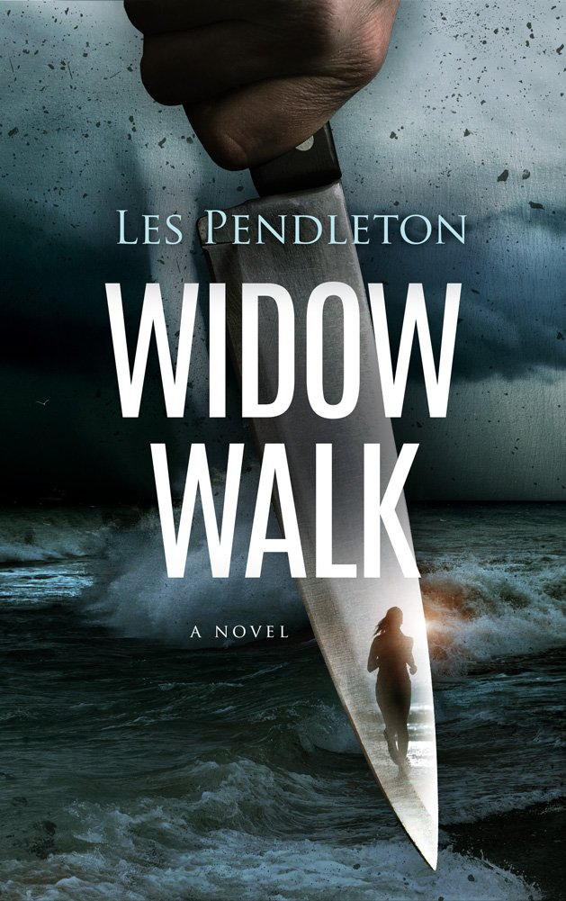
When a lonely young woman and an unusual stranger meet in the small coastal town of Beaufort, North Carolina, their romantic liaison is thrown on the rocks by the simultaneous arrival of an intense hurricane and a vicious serial killer preying on the town’s women. Sarah Turlington has led a quiet and sad existence in her small hometown by the sea. After suffering a brutal attack on her first experience away from home, she has retreated to the security of the one place she feels safe. It would have been easy to just live out her days there in quiet solitude until a young artist and adventurer wandered into the small gift shop where she worked. He was the outside world and he wanted into hers. Just as she started to develop the trust needed to have any sort of involvement with him, Beaufort becomes the backdrop for a series of attacks by a brutal serial killer. At the same time, a massive hurricane threatens to remove the town from the map. Sarah’s decision to trust would force her to risk her own life and perhaps the lives of others. There is a point at which nature, love, trust and evil will all intersect.

